OTHER EVALUATIONS (*):
Members | Task Details
Member 1 | 13 Questions and Expand - 100%

TASK ASSIGNMENT TABLE:
Content | Result
Average total time to complete the lab (1) | 10 hours
Video Link (2)
(if any)
Feedback (3) (if any)
+ Challenges
+ Suggestions …
Self-Assessment Score (4) | 10/10
(*): Sections (1) and (4) are mandatory.

Teacher: Phan Trung Phát

Name | ID
Trần Anh Tuấn | 24521943

HTTP Protocol
2

Question 1: Is the browser using HTTP version 1.0 or 1.1? What is the version of HTTP server in use?

Evidence:
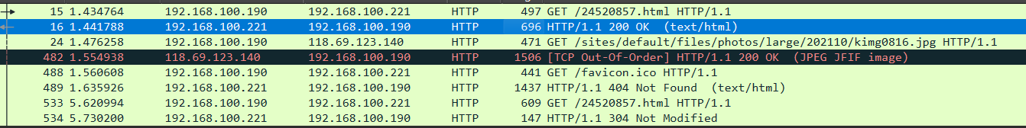

Explanation
I’m using client browser (Microsoft Edge) to initiate an HTTP request using HTTP version 1.1, as indicated by the line 11: GET /24521943.html HTTP/1.1. The corresponding server response, as line 14: HTTP/1.1 200 OK, confirms that the server also operates on the same HTTP version 1.1.

Question 2: What is your computer's IP address? How much is the web server's?

Evidence:


Explanation:
My IP address 192.168.100.190, while the web server has the IP address 192.168.100.221.

Question 3: What is the status code returned from the server?

Evidence:
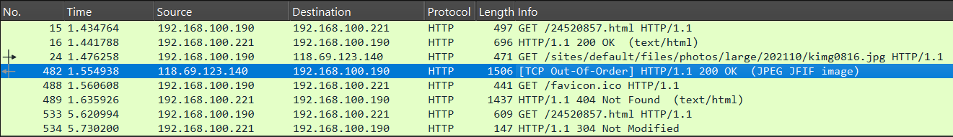

Different status codes appear doing Exercise 1

Explanation:
The most important status codes appear first is 200 OK, which indicates that the server successfully received and fulfilled the client’s request by returning the requested HTML page or image. 404 Not Found response shows that one of the requested resources was missing, 304 Not Modified response confirms that a previously cached resource was still valid and did not need to be re-downloaded.

Question 4: How many bytes of content did the server return to the browser?

Evidence:
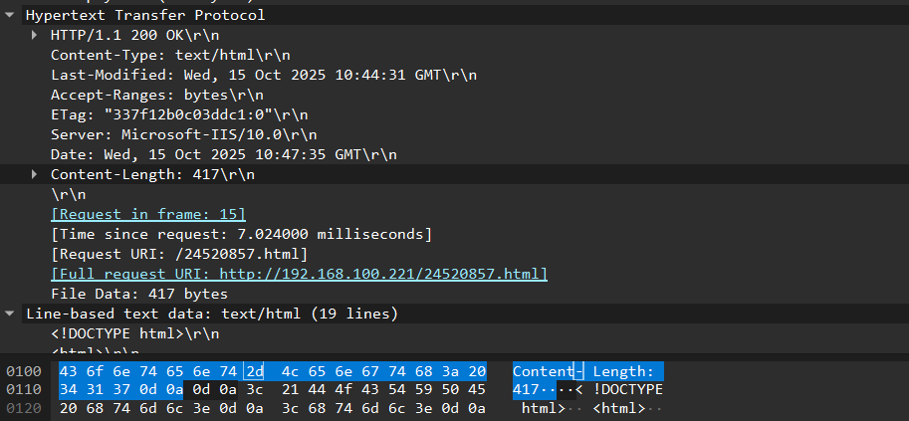

Explanation:
The header field Content-Length: 417 specifies that the web server returned 417 bytes of data to the client browser. Because the website in the example doesn’t support for Vietnamese language so I need to put some extra lines of codes <meta charset="UTF-8"> to display Vietnamese characters (which contain more bytes than the given example).

Question 5: Review the contents of HTTP GET first. You can see the line “IF-MODIFIED-SINCE” or not?

Evidence:
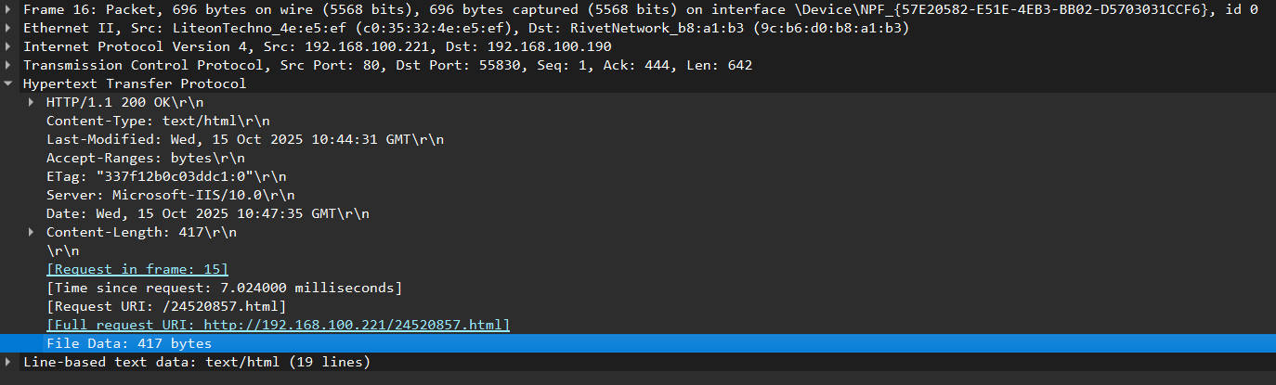

Explanation:
There is no “IF-MODIFIED-SINCE” in the contents of the first HTTP GET.

Question 6: Consider the content of the response from the server. Is the server really returning the contents of the file HTML or not? Why?

Evidence:
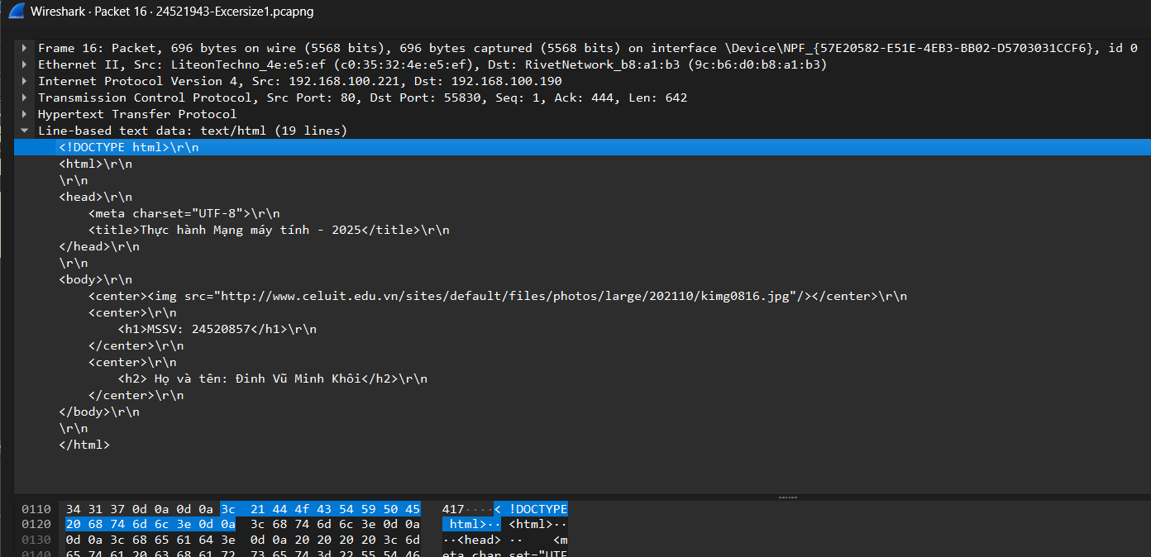

Explanation:
Based on the Wireshark capture, the server is returning the actual contents of the requested HTML file. The response includes the status line HTTP/1.1 200 OK and the header field Content-Type: text/html, indicating that the response body contains an HTML document. Furthermore, the data section of the packet shows the beginning of the HTML structure (<!DOCTYPE html> and <html> tags), which confirms that the server transmitted the complete HTML page to the browser.

Question 7: Examine the contents of the 2nd HTTP GET. Do you see the line “IF-MODIFIED-SINCE” or not? If yes, what is the value of IF-MODIFIED-SINCE?

Evidence:
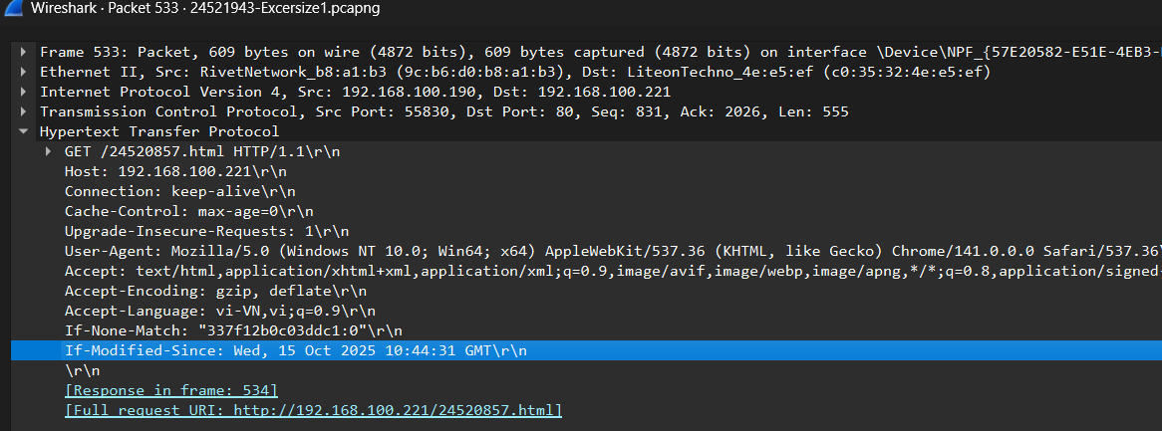

Explanation:
Yes, the second HTTP GET request includes the header field If-Modified-Since. Its value is Mon, 15 Oct 2025 10:44:31 GMT, which matches the “Last-Modified” timestamp from the server’s previous response.

Question 8: What is the HTTP status code returned from the server corresponding to the 2nd HTTP GET? What does it mean? Is the server really sending back the contents of the file? Explanation.

Evidence:

Explanation:
In the second HTTP GET request, the server responded with the status code “HTTP/1.1 304 Not Modified.” This indicates that the requested file 24520857.html has not been altered since the timestamp specified in the client’s If-Modified-Since header. As a result, the server does not retransmit the HTML file content; instead, it instructs the browser to reuse the previously cached version.

Question 9: How many HTTP GETs did the browser send? To which IP addresses?

Evidence:
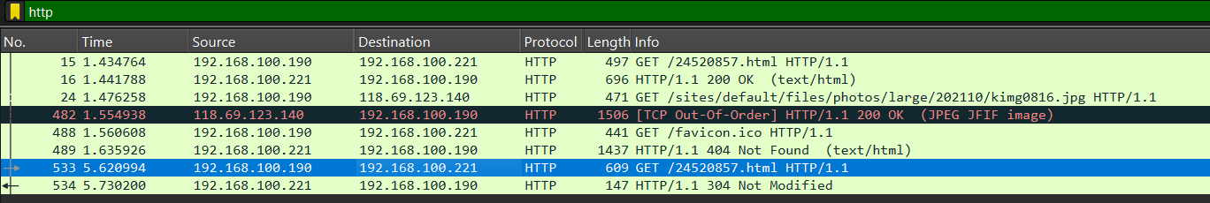

Explanation:
The browser issued a total of four HTTP GET requests. Three of these requests were sent to the local web server at 192.168.100.221 (for the main HTML file 24520857.html and favicon.ico). One request was sent to an external web server at 118.69.123.140 to receive an image file which is included in the main html file and was successfully received with HTTP/1.1 200 OK and the header field Content-Type: JPEG JFIF image

Question 10: How many HTTP GETs did the browser send? The line “THE BILL OF RIGHTS” is contained in what response packet?

Evidence:

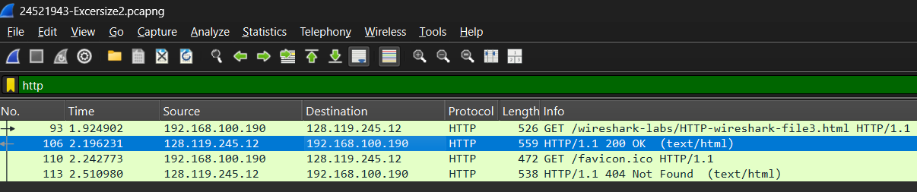
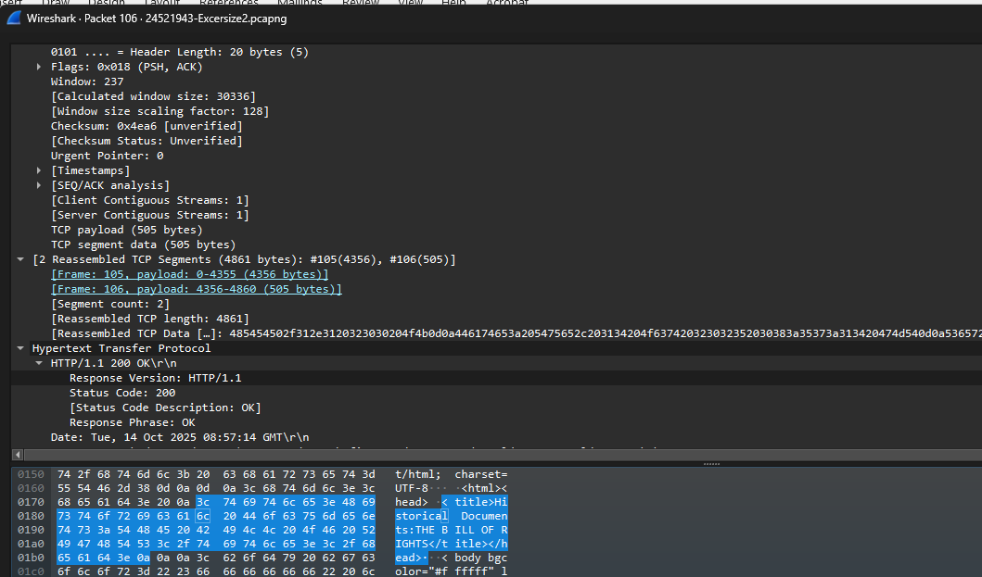

Explanation:
In this capture, the browser issued a total of two HTTP GET requests—one for the HTML document and another for the favicon.ico file. The server responded to the first request with HTTP/1.1 200 OK, returning the complete HTML page. The line “THE BILL OF RIGHTS” is contained in (#105) TCP Segment, which contain first 0-4355 bytes from the HTML.

Question 11: How many TCP segments does it take to contain the HTTP response and the content of The Bill of Rights?

Evidence:
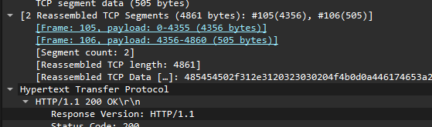

Explanation:
In your Packet 106 details, Wireshark shows at the very top of the reassembly block “[Segment count: 2]” for the HTTP/1.1 200 OK response. That response contains the HTML with the line “THE BILL OF RIGHTS” and a Content-Length: 4500 bytes body. Wireshark reassembles those bytes (headers + body) from two TCP segments, so it took 2 segments to carry the full response payload.

Question 12: What is the status code and what it means in the HTTP response corresponding to the first HTTP GET?

Evidence:
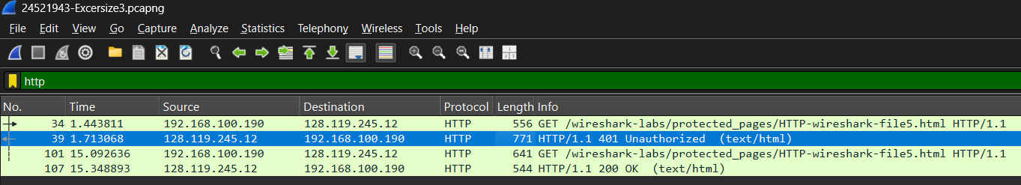

Explanation:
In response to the first HTTP GET request, the server returned the status code “HTTP/1.1 401 Unauthorized.” This indicates that the requested resource resides in a protected directory and cannot be accessed without proper authentication credentials. The server requires the client to provide a valid username and password before allowing access to the page. This is part of the HTTP authentication mechanism designed to restrict unauthorized users from viewing confidential content.

Question 13: When the browser sends the HTTP GET for the second time, what new fields appear in the HTTP GET?

Evidence:
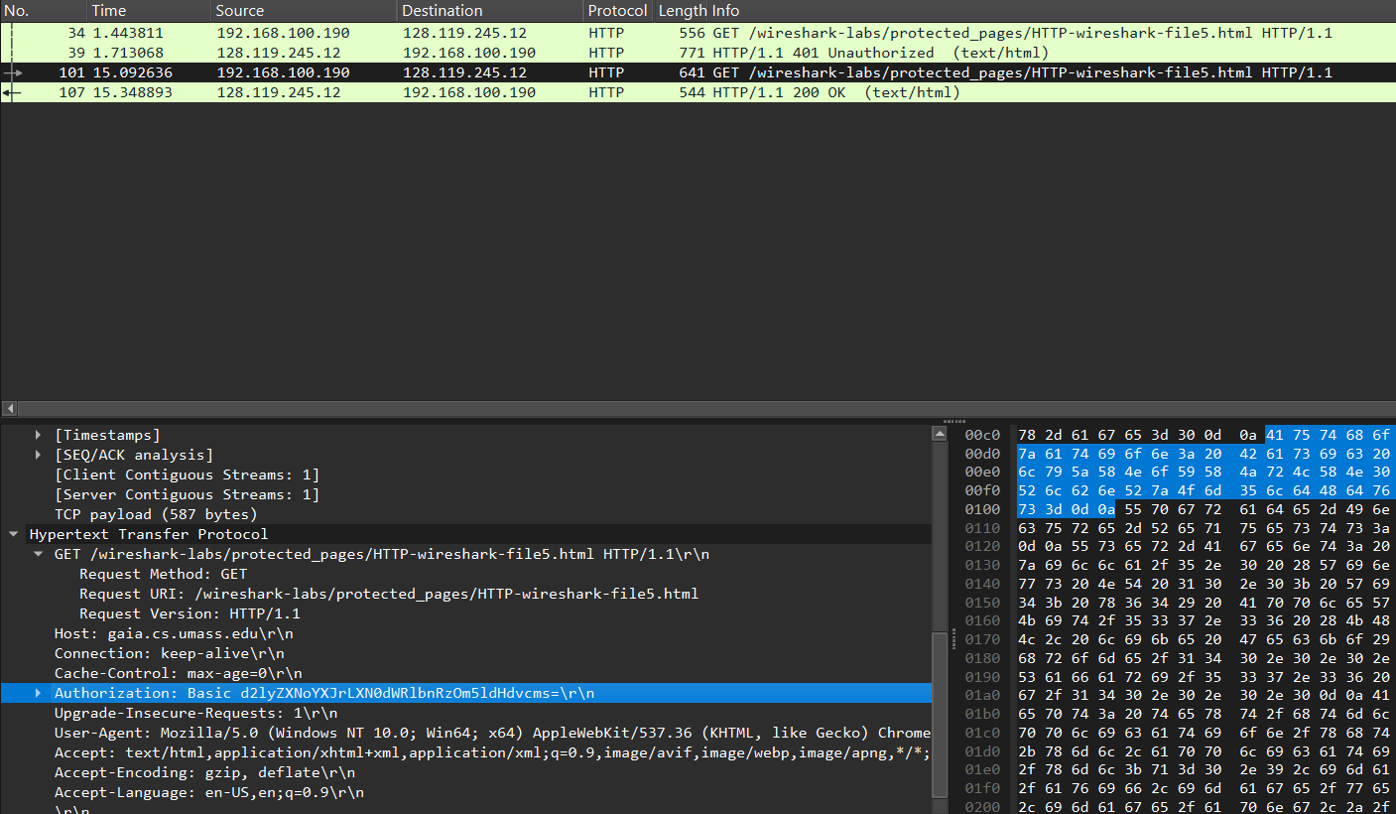

Explanation:
When the browser resends the HTTP GET request after the initial 401 Unauthorized response, a new header field—Authorization—appears in the request. This header contains a string representing the username and password used for HTTP Basic Authentication. The inclusion of this field allows the client to prove its identity to the server. Once validated, the server responds with HTTP/1.1 200 OK, confirming that authentication was successful and access to the protected resource has been granted.

END

